**Application Overview**

In this application we used WEB Api’s for all the curd operation. In this solution we have two project first one is Inventory project and another one is logic layer.

In Logic layer all the database access method and entity class is store and in inventory project over controller is place which is use for web api call’s.

Here you can see the projects-----------------

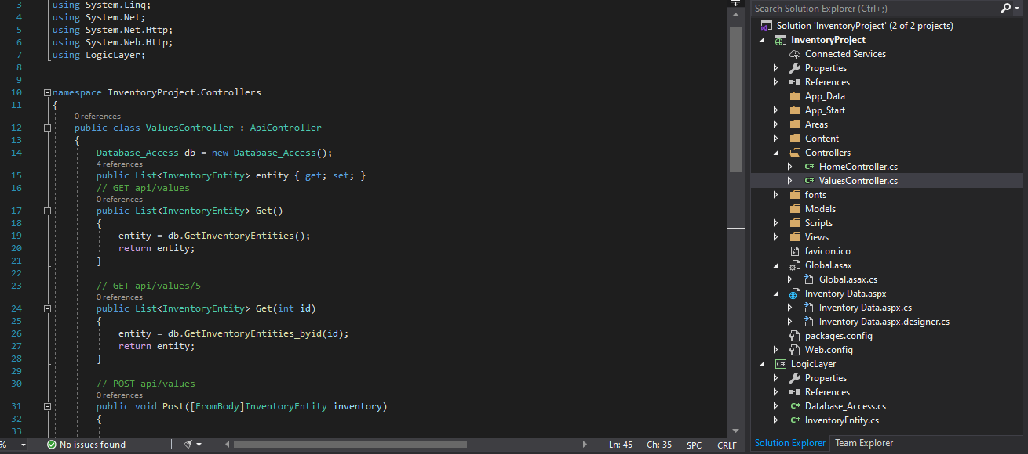

Now you can the api call’s for api calling I used postman application because it’s much easier then other api calling tools.

Here you can see we have three rows in inventory table

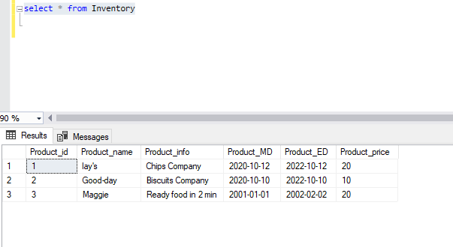

Same data fetch by postman using get method and end point is also mention in screen shot.

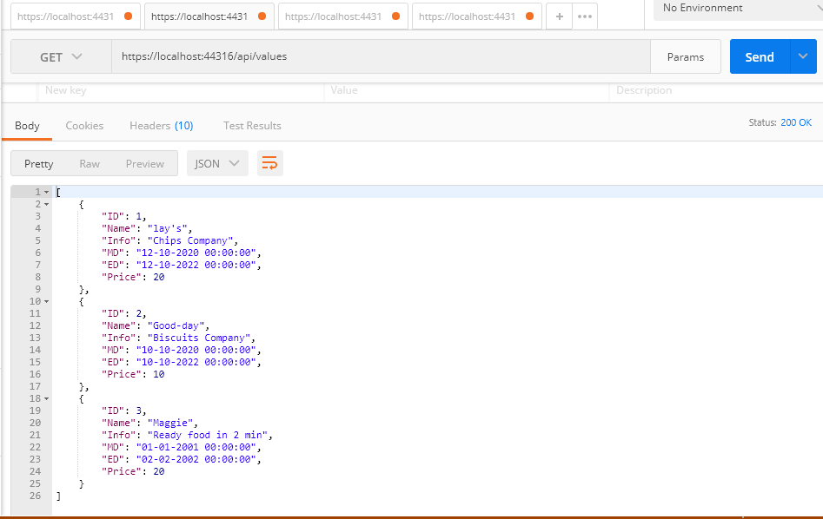

Now next method is post method which is use for create the new entry in the database

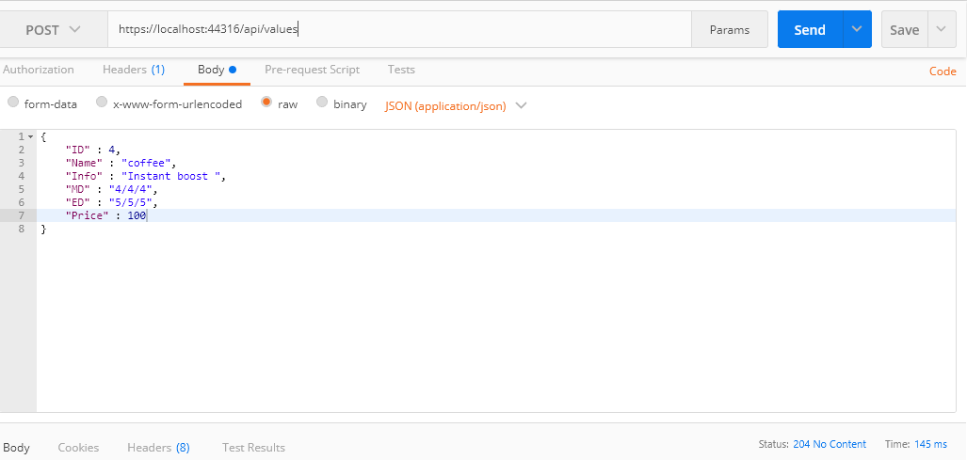after running this method database also updated

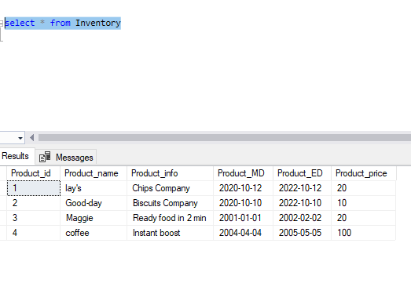

Now , if you want to update any entry with respect to id here so now I take id number 3 and just update Maggie to noodles.

This is the request and we used put method for this

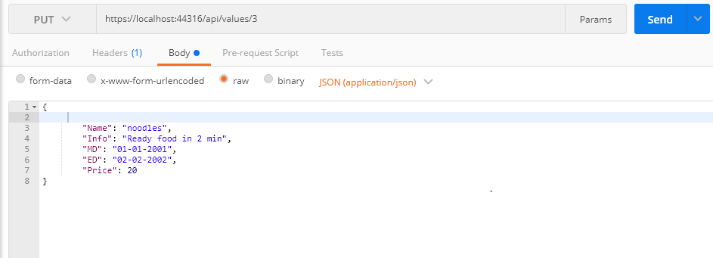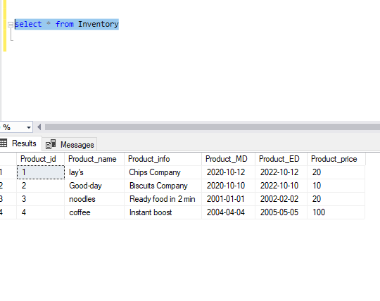

Here you can see row number 3 is updated successfully.